Site recovery vaut

1. Create resource group in WEST US
2. Create Virtual machine through portal

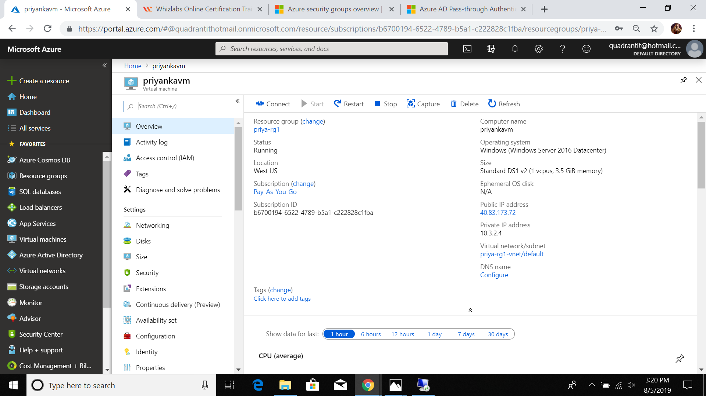

1. Go to “backup and Recovery vault” -> create recovery vault in different resource group with diff location (WEST US 2)

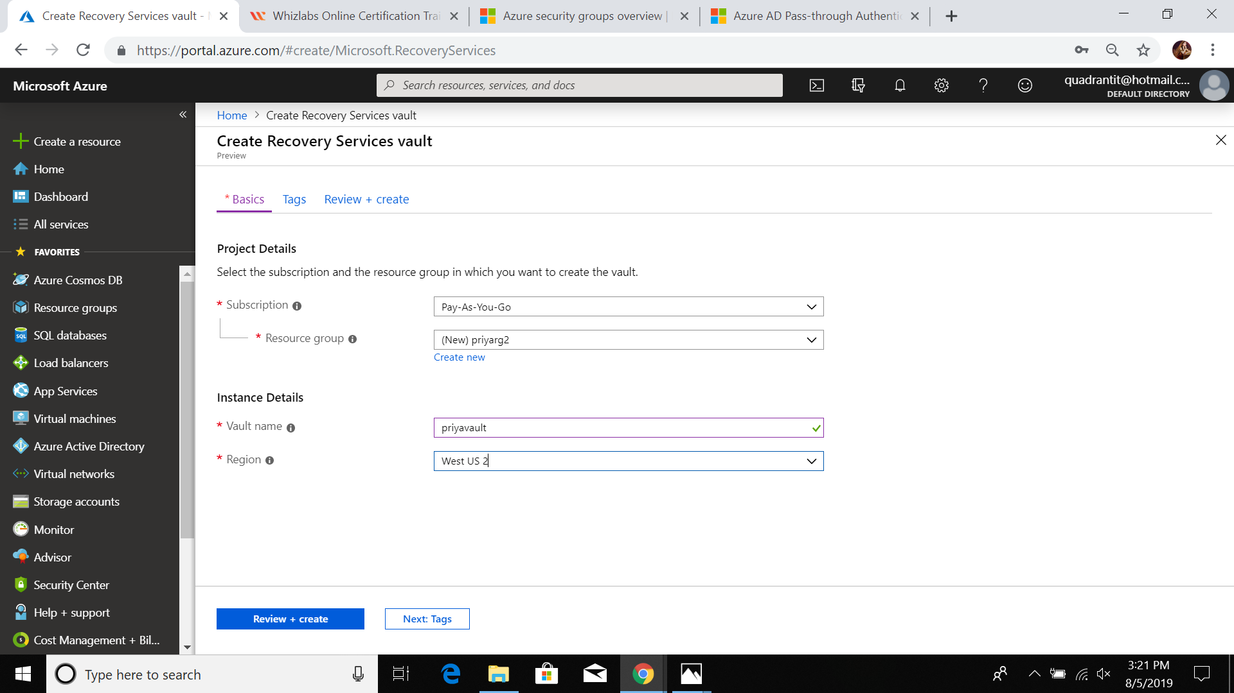

4.goto priyavault-> replicate.

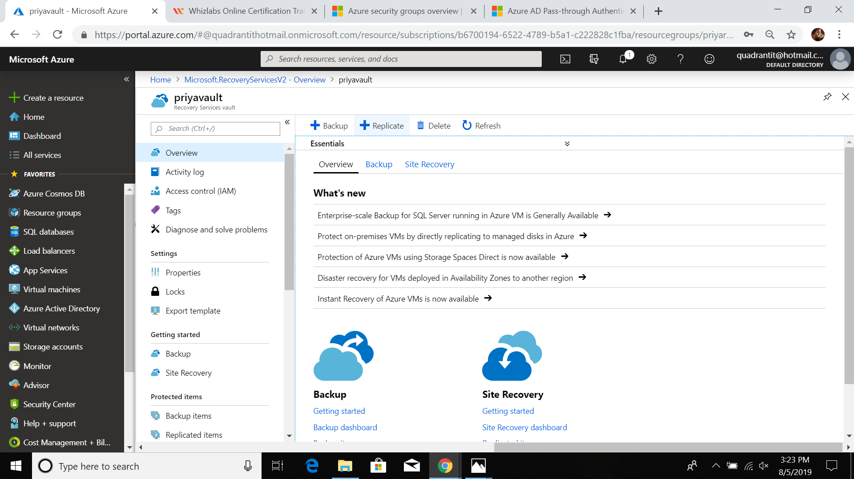

5.Give source resource group name and location.

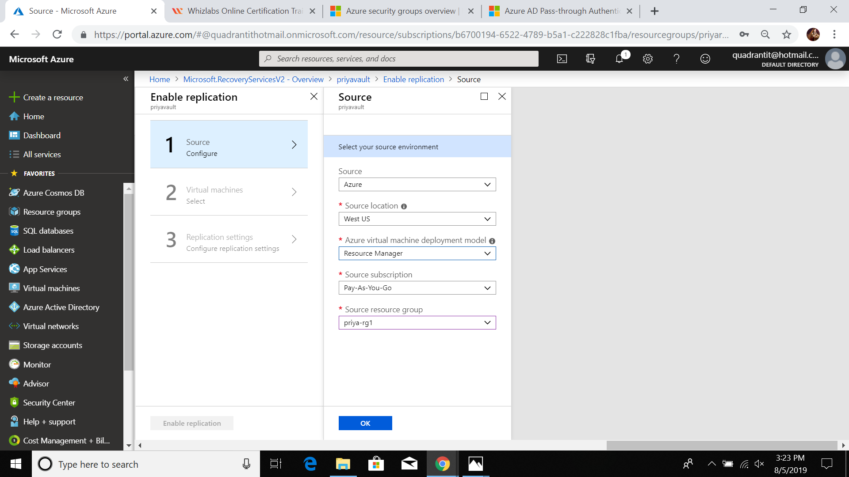

6.Select virtualmachine

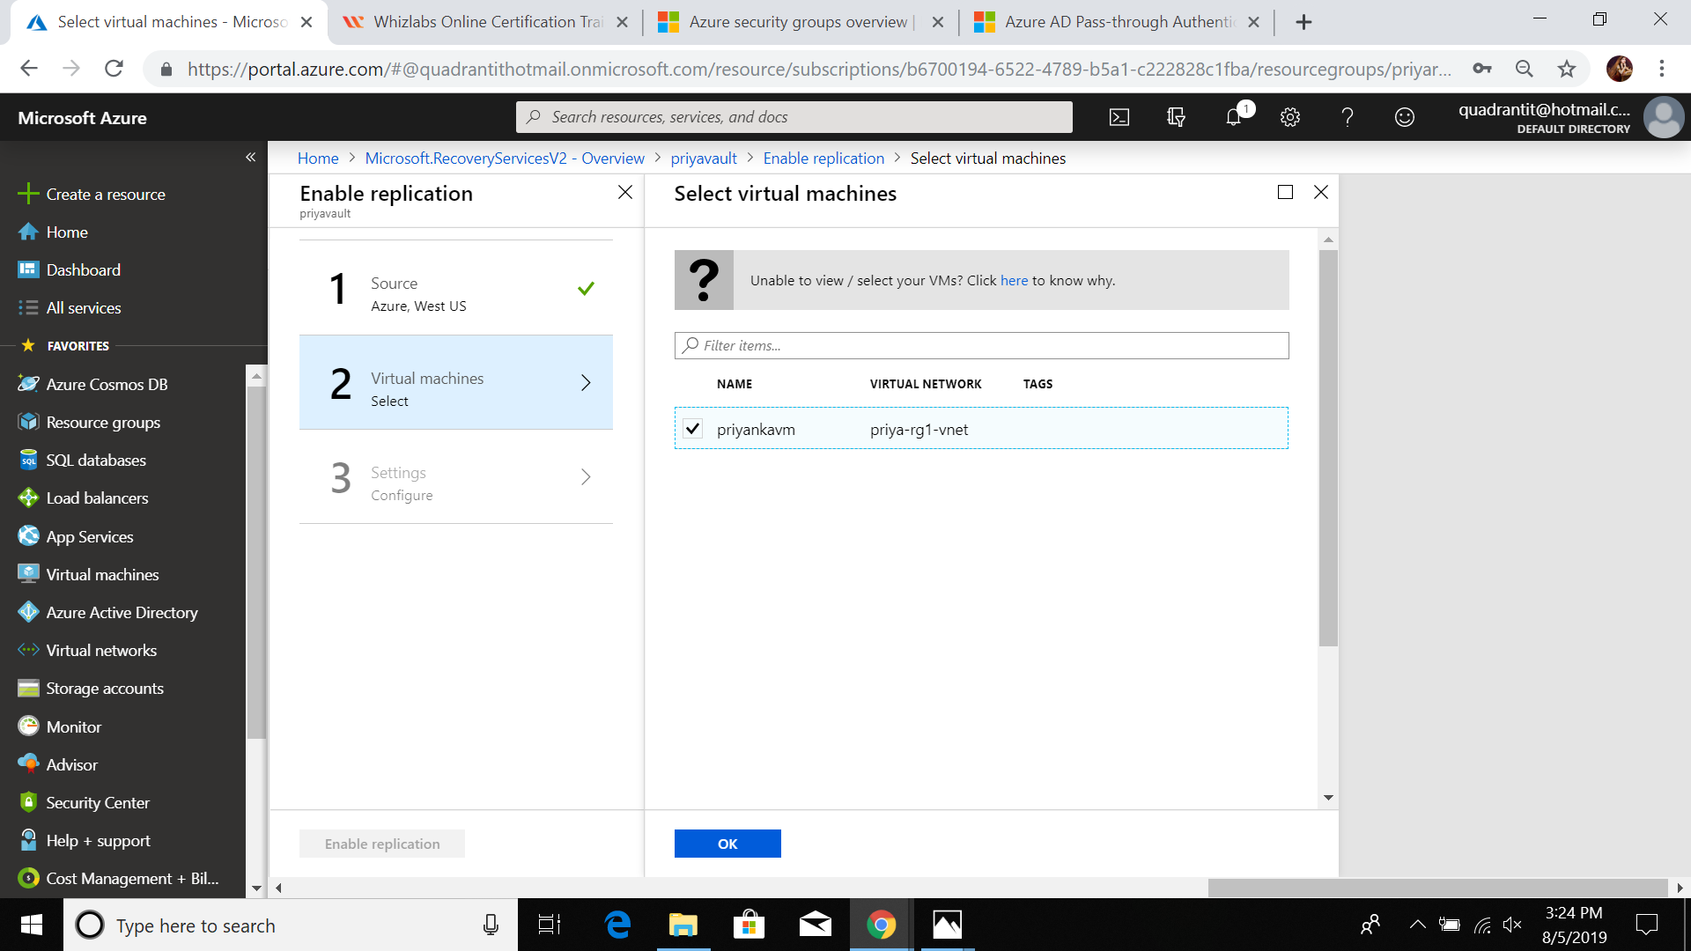

7.In settings give target location (west us 2)

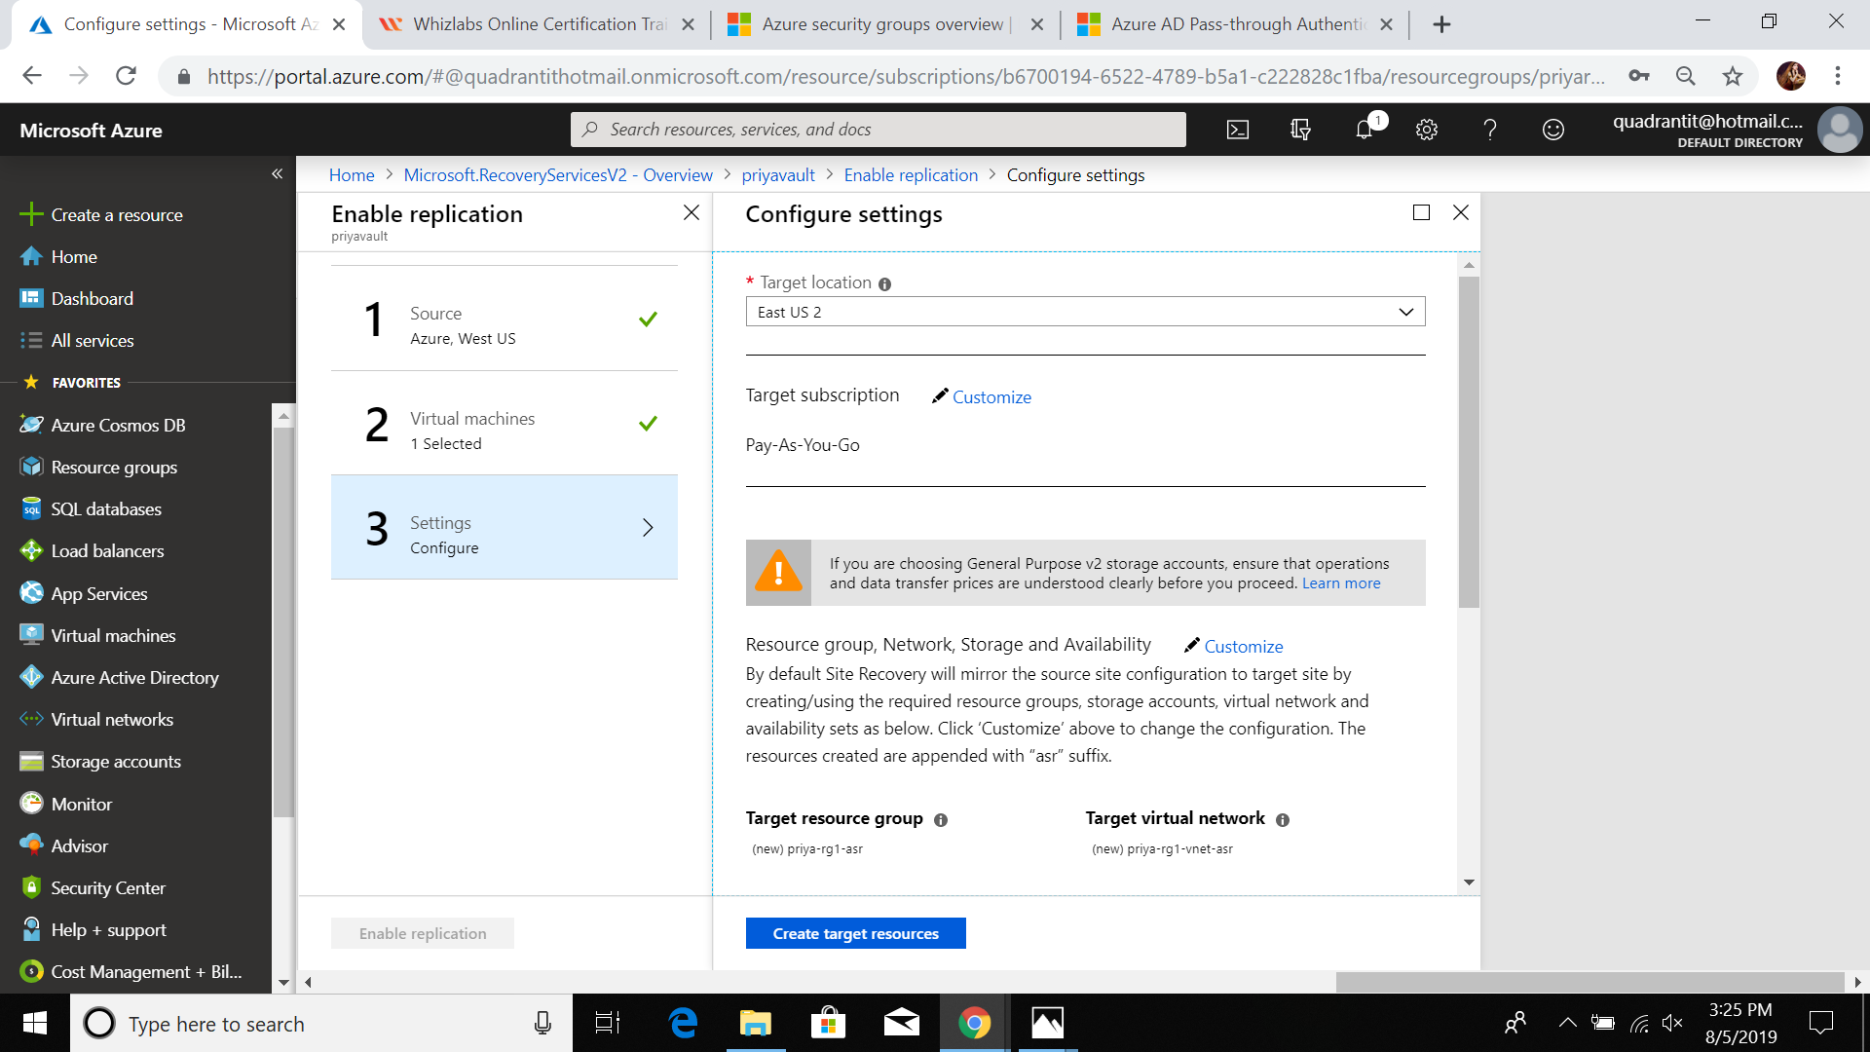

8.Create traget resources than enable replication

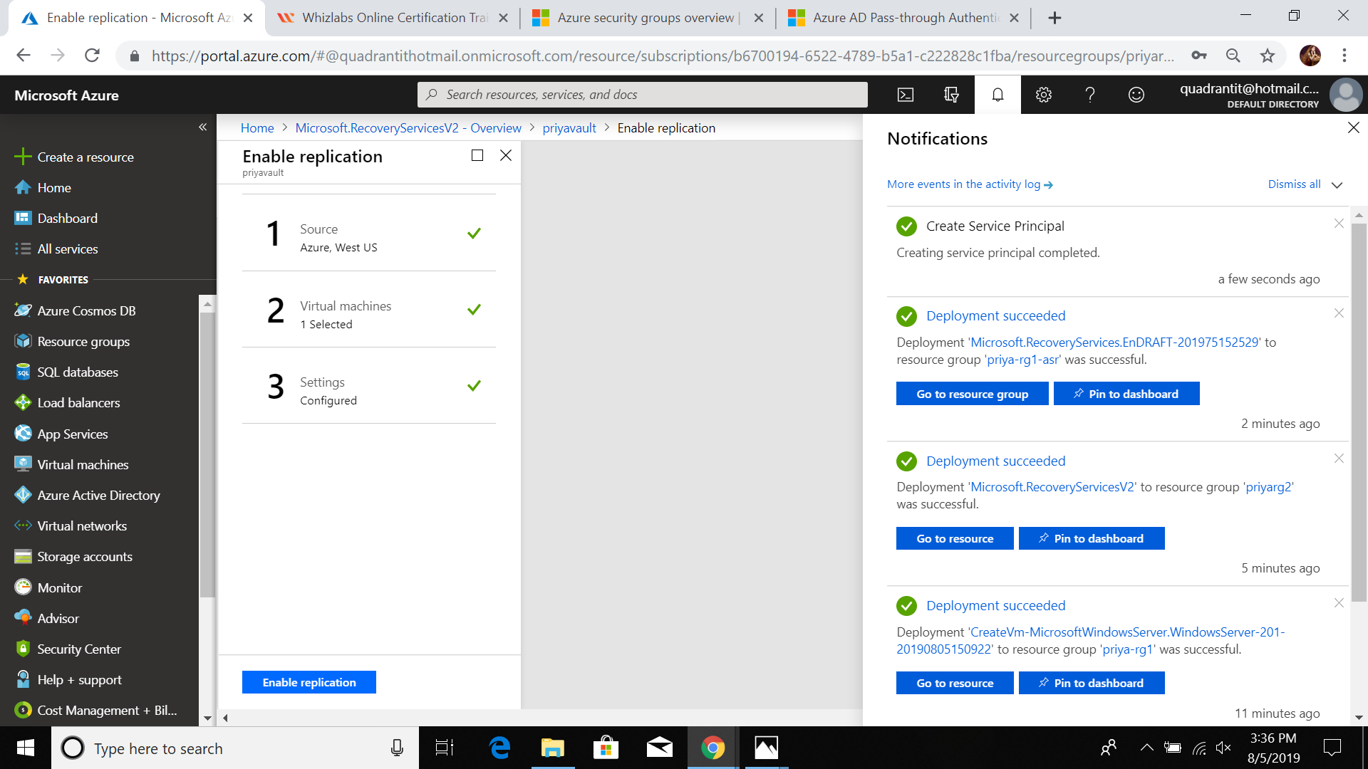

9. Replication of vm succeeded.

